EXECUTIVE SUMMARY

**Business idea:**

The idea of our product is to create an easy to use application that can help the people of the world keep track of how much they make passively. Without having to do any of the calculations or hours tracking that many people are terrible at doing. In todays world time is money. And when people are working 40-hour weeks and going to school or having a family. It gets hard to keep track, while also making it easy for companies to make errors. Resulting in the loss of wages. Which short term is but long term can accumulate into a grander sum of lost wages that can go completely un-noticed? Flow tracker can end this trend.

**Key Points:**

The main purpose and function of our application is to track hours of worked by the user. It will access the scheduled work events that are in the user’s calendar. Using these tracked periods of time the application will calculate the user’s money earned. In order to do this the application needs a few things from the user to complete the algorithm. First the user must input their hourly rate of pay, so that the application can properly track how much the user makes while at work. Then the user needs to input the rate that they are taxed in their state or province. This will allow the application to make the proper deduction of tax. This way the amount that the application presents to the user as the amount they will make on their next check is completely accurate right down to the cents.

**Why choose Flow Tracker:**

Flow tracker will be the best option for people who want to keep track of how much they are making. Nobody likes having to fix incorrect paycheques but having flow tracker will make it easier to catch these errors, and fix them. Whether the mistake was by accident or on purpose, fixing an honest mistake or catching a time thief. This application can protect your money as well as help you plan better for the future. Knowing how much you will have when pay day comes helps people not overspend. The answer to saving money is mindfulness and that is the overall goal of our application. To help employees calculate their money and by calculating their money we plan to give people the ability to know how much they make before they make it. By knowing how much you will make before you get paid will enable the people to also not spend more than they have, because they will now exactly how much will be in their account at any given time.

Project Requirements

**Functional**

* User login- user will input their email, password.
* User input variables- user must input their hours/ pay and the tax that is taken off their check.

**Non functional**

* Calculations- compute the variables that the user inputted.
* Display- show the user the final value after calculations

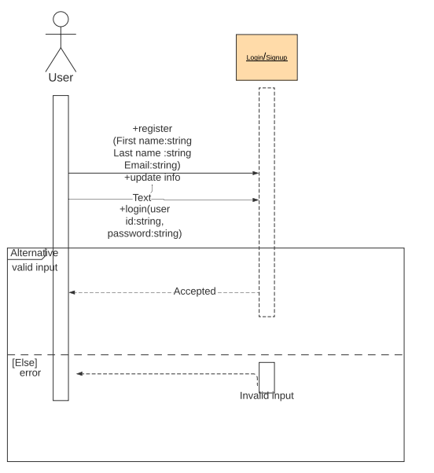

Project experience

This project proved to be challenging in some areas for me while not for Pavan, and vice versa. There were a couple of hiccups while we tried to complete the tasks given to us Pavan had a better time making his git-hub repository commit. While mine got jumbled a few times forcing me to restart. While I had a better time understanding how to draw up the use case diagram. Mostly since the project idea that we decided to use was mine. Which made visualizing and physically representing the processes in the use case diagram easier for me. The team work between Pavan and myself was awesome. We met up outside of class time and got what needed to be done finished. While also having a good time doing. We would talk about it in our other classes to make sure we were on the same page. Overall this project was a straight forward one because what we didn’t understand individually, we were able to figure out as a team.

Conclusion

The ease of access of Flow tracker being on mobile gives the power to ensure the proper amount of pay is received by the user. The easy to understand break down of said amount will allow for peace of mind and financial security for the user. Flow tracker requires very simply tracks the user’s hours worked and can be set up to coincide with your scheduled paycheques. This application has the potential to revolutionize the confidence people will have in the amount they are paid and how much they can spend